CollegeUp.org Forum Moderator Guidelines

As a CollegeUp.org forum Moderator you will use your skills as a Customer Relations Representative to provide answers to the CollegeUp.org user questions. As a forum moderator you will have the ability and user’s rights to enforce the rules of the CollegeUp.org forums. You will also have the power to close or lock discussions to prevent particular CollegeUp.org users from continuing to use the forums.

CollegeUp.org Forum Moderator Role

The CollegeUp.org forum moderator will enforce forum rules and conduct basic administrative tasks that can't be trusted to ordinary CollegeUp.org users. Forum moderators will stop flaming and make sure the CollegeUp.org forum is a friendly place that is free from personal attacks, illegal content (warez) and pornography. The CollegeUp.org forum prohibits the use of swearwords and any violent or sexual images
or text.

The CollegeUp.org forum moderator will also answers any users’ questions. Many of the users’ questions will be on student loan related topics. Your role as Customer Relations Representatives will allow you to provide the CollegeUp.org user base with many relevant answers to specific student financial aid, student loan and USA Funds questions. CollegeUp.org forum moderators will use alternate accounts to engage CollegeUp.org forum members. CollegeUp.org forum moderators may participate just as any normal collegeUp.org user provided they remain civil and obey the CollegeUp.org terms and forum rules.

As a College Up.org forum moderator you will:

• Respond to user questions, comments and suggestions.
• Moderate forums using the CollegeUp.org forum rules.
• Edit and/or approve content contributions made by users.

CollegeUp.org Forum Rules

These rules apply to ALL CollegeUp forum categories, threads and posts:

1. We take the "Be Polite" rule very seriously. We do not tolerate any rudeness. Any member who is intentionally unpleasant or disruptive may be banned without warning.

2. Any posts that encourage illegal intent will be removed and the account banned.

3. You may not link, in any manner, to sites or images containing pornography, sexually explicit, gross violence, or are determined by moderators to be detrimental to the community.

4. If you SPAM our members in any manner, your account will be disabled. Do not contact anyone to suggest your product or service who is not explicitly expecting you to contact them from an advertising forum post.

5. Your account is yours alone. You are responsible for any activity created with it. You may not share your account log-in with anyone. If you choose to ignore this important restriction your account, and any accounts associated with it, will be disabled.

6. You may not post commission, referral or affiliate links anywhere on the forum.

7. You may not post words or URLs that are censored by adding spaces, dots, or substituting characters; or by any other means in an attempt to defeat any censors. Please contact us if you feel a word or URL is unjustly censored.

8. Public posts debating these rules and/or moderators' enforcement of such, will be removed without comment. We encourage feedback however and invite you to use our help desk if you have any questions or concerns.

CollegeUp.org Forum Moderator Responsibilities and Enforcement Methods

Listed below are the CollegeUp.org forum responsibilities and enforcement methods for CollegeUp.org forum moderators (Customer Relations Representatives):

Deleting Posts - CollegeUp.org forum moderators must remove (delete from public view) illegal or grossly offensive forum posts from the CollegeUp.org forum. Here are the steps to delete a post:

1. Click on Recent Topics to see the current CollegeUp.org Forum posts.

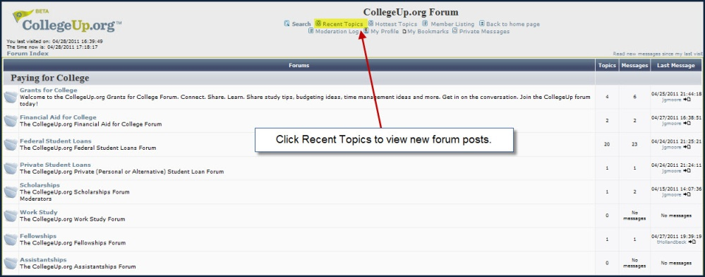

2. Click on any inappropriate or offensive forum post.

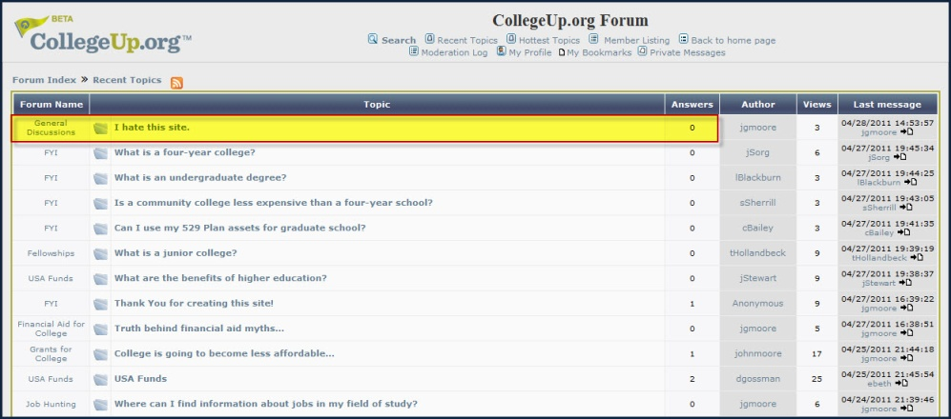

3. Click on the (X) icon located at the upper-right corner of the post.

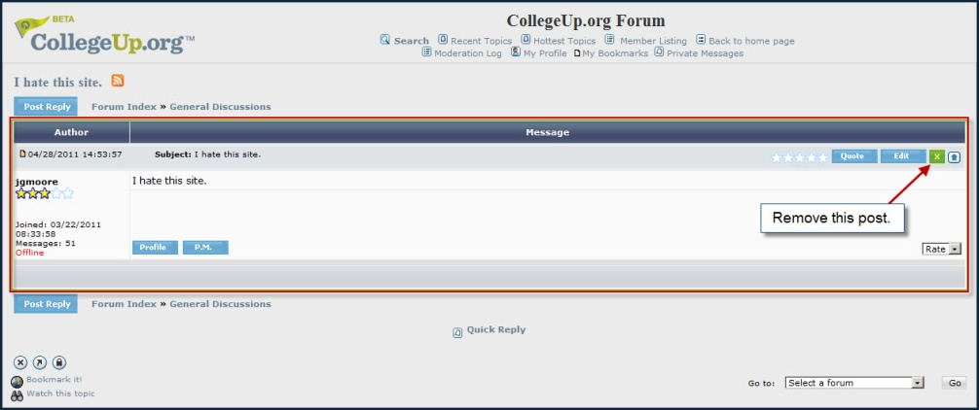

4. Click the OK button to remove the inappropriate or offensive post.

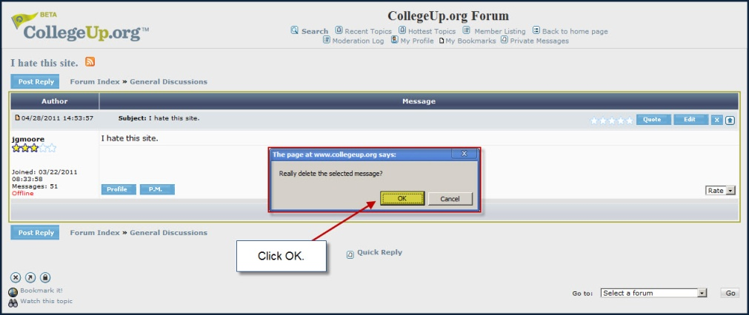

5. Enter your Change Reason and click the OK button.

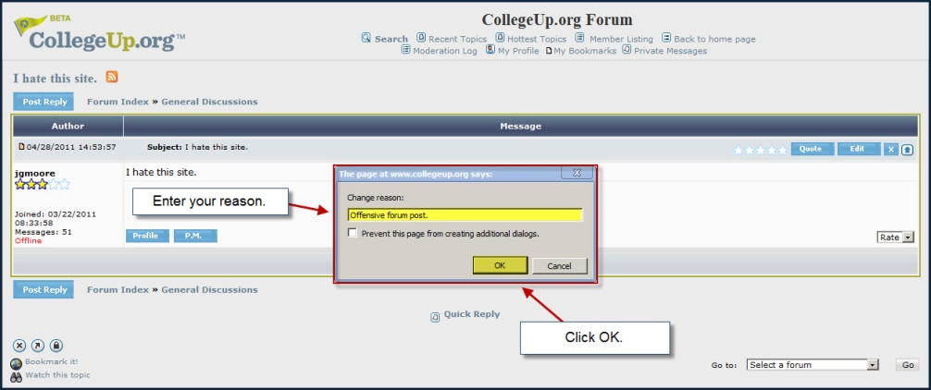

6. The inappropriate or offensive forum post has been removed from the CollegeUp.org forum.

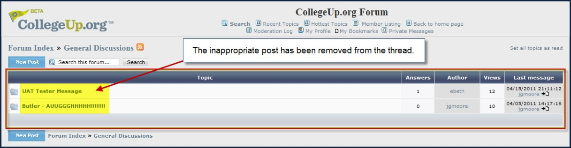

Editing Posts - If a post is made that contains only some content that breaches forum rules, CollegeUp.org forum moderators must remove that content while still leaving any legitimate content. Even if an entire post is removed via editing, users will still be able to see who originally posted it and when it was originally posted, so that users who view the thread later won't be confused by any references to deleted content. Usually this method is used to remove illegal or grossly offensive material that would remain visible in a closed thread, or else to stop a single post from derailing an entire thread. Here are the steps to edit a post:

1. Select a post you want to edit by clicking the post to open it.

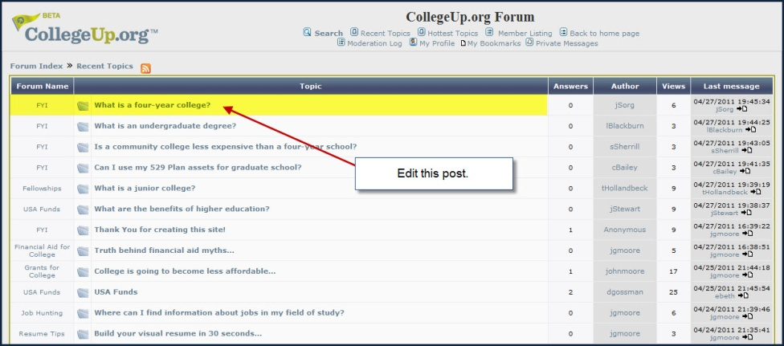

2. Click on the Edit icon located at the upper-right corner of the post.

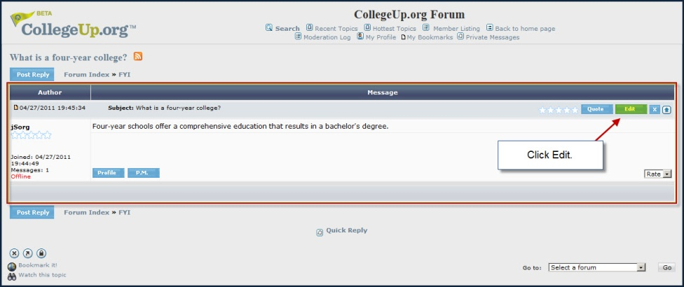

3. Use the post editor to make edits to the content.

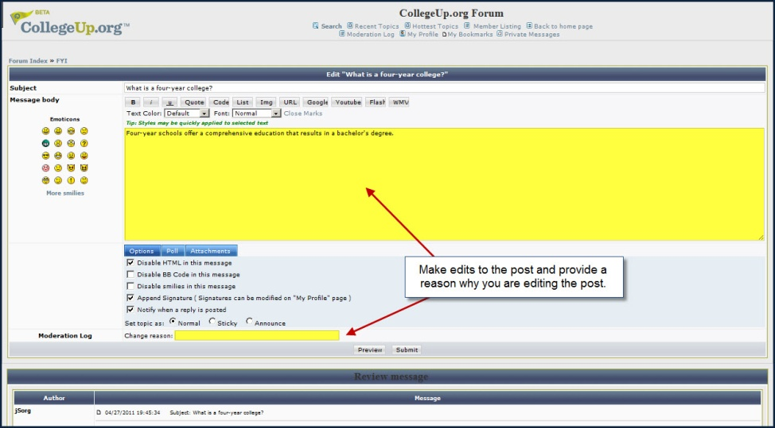

4. Click the Preview button to see how the edited post looks.

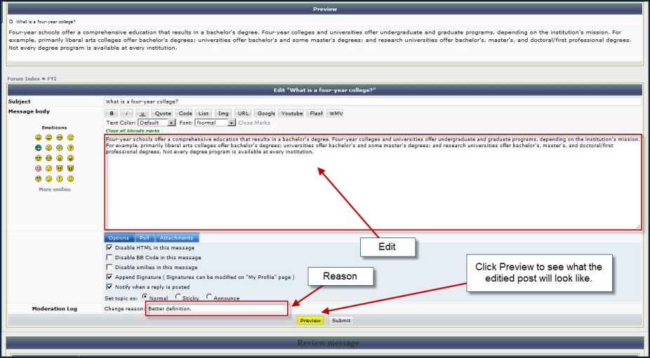

5. Click the Submit button to update the post to the CollegeUp.org forum.

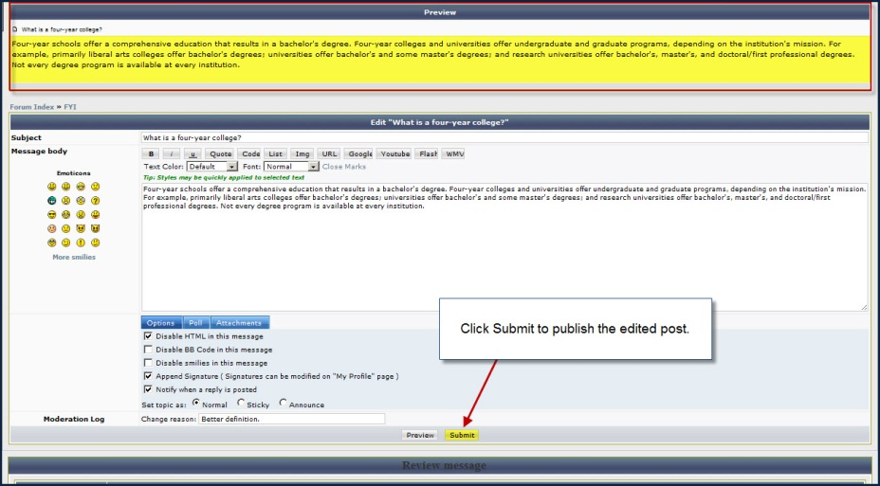

6. The updated post is now available on the CollegeUp.org forum.

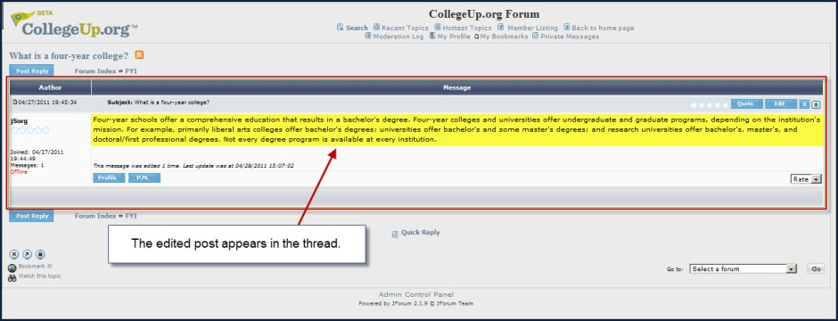

Banning Users - CollegeUp.org forum moderators must remove users who post illegal or grossly offensive content to any of the threads on the CollegeUp.org forum. Here are the steps for banning a user from the CollegeUp.org forum:

1. Click on Admin Control Panel located at the bottom of the CollegeUp.org Forum.

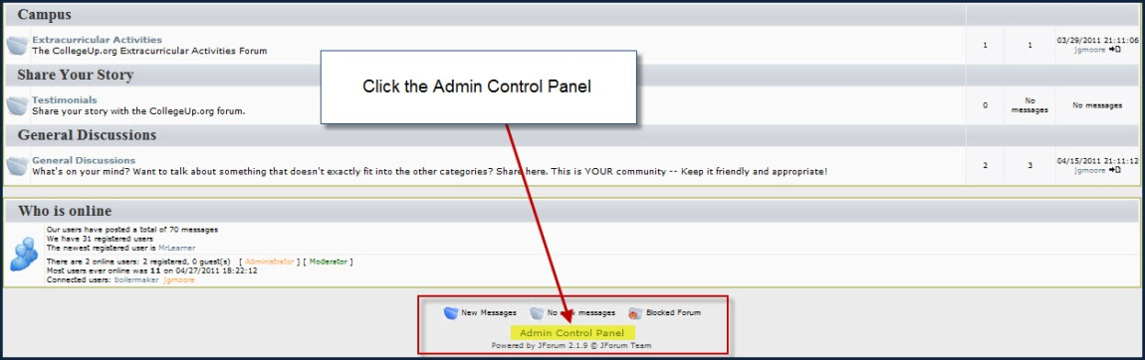

2. Click on Banning located on the Administration panel.

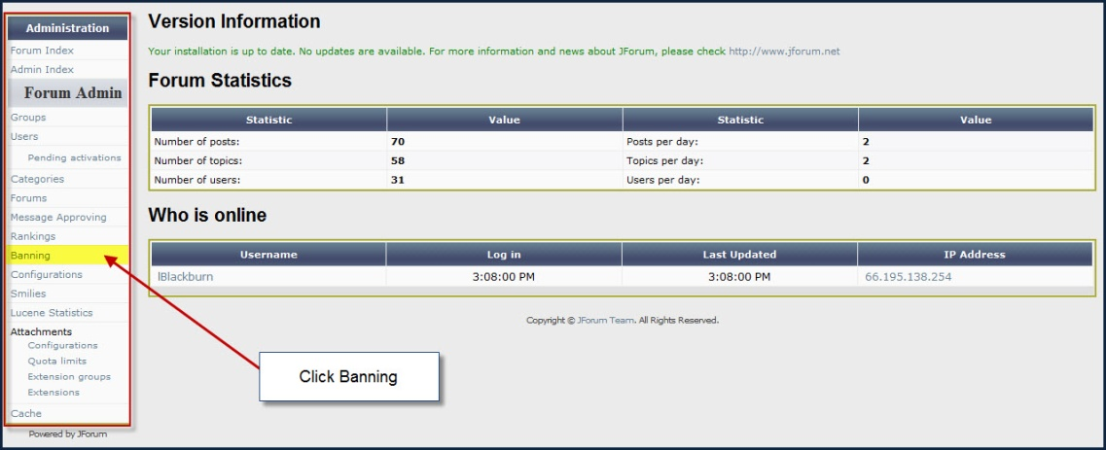

3. In the Banning List panel click the Insert new button.

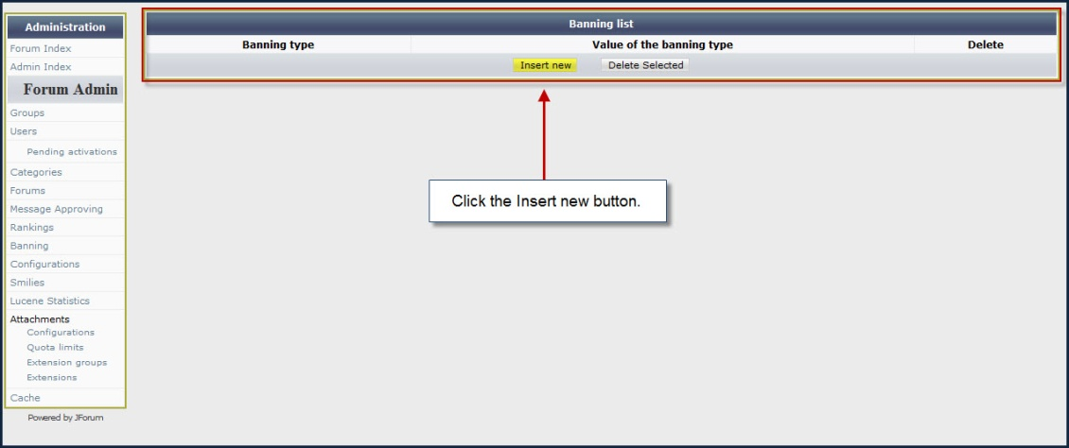

4. In the Add new Banning panel, enter banning type information. Select By User ID.
Enter the user ID of the user you want to ban and click Update to ban a forum user.

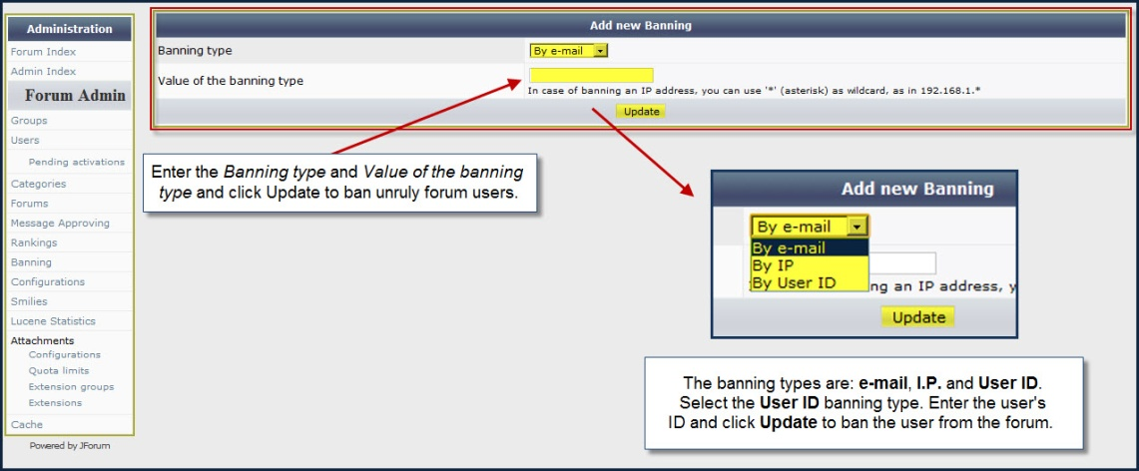

Deleting posts, editing posts and banning users are effective enforcement methods for CollegeUp.org forum moderators. These simple and easy methods will provide the CollegeUp.org forum moderators the ability to enforce the rules of the CollegeUp.org forums.

CollegeUp.org Forum Moderator Overview

The College Up.org forum moderators must check frequently—at least four times throughout the day—for any changes to the forum. While evaluating the CollegeUp.org forum content use the CollegeUp.org Forum Rules as a guide and always ask yourself:

• Is this post appropriate (considerate, polite, and helpful) in general?
• Is this post appropriate to the College Up.org forum topic?
• Is this an honest post or topic to be on the College Up.org forum?
• Is this post spam, phishing, or abusive to the CollegeUp.org Forum?

If the answer to any of these questions is yes, use the CollegeUp.org forum enforcement methods to correct the problem. As College Up.org forum moderators it's important to remember, anyone can view these posts, including children, grandmothers, pastors, school administrators, business leaders and others. The College Up.org Forum Moderator Guidelines will ensure the College Up.org Forum is a safe, friendly and useful shared resource for CollegeUp.org users.

CollegeUp.org Forum Moderator Account Information

Here is the Customer Relations Representative Collegeup.org Sign In information:

Username: jStewart  Password: changeme | Username: tHollandbeck  Password: changeme | Username: cBailey  Password: changeme
Username: sSherrill  Password: changeme | Username: lBlackburn  Password: changeme | Username: jSorg  Password: changeme

