eLMS ADMINISTRATOR GUIDE

Version 1.0

January 2010

Basic Tasks for eLMS Administrators

Overview | This document contains directions to help administrators get started with tasks surrounding setting up and managing courses in eLMS, Clarian’s eLearning Management System.  This document covers the following topics:  Create Scheduled Offerings: Page 03  Setting Registration Parameters: Page 10  Registering Users for a Scheduled Offering: Page 12  Canceling a Scheduled Offering: Page 15  Printing Rosters: Page 17  Complete Scheduled Offering Roster for Completion Status: Page 21  Editing Completion Status with the Learning Event Editor: Page 24

Basic Tasks for eLMS Administrators, Continued

Creating Scheduled Offerings | Need to add times and locations for your courses?  Follow the instructions below to create scheduled offerings on eLMS.  Note: The following instructions are for existing courses that have already been entered into eLMS—i.e. The Gift of Care giving, Cerner courses, etc. For completely new courses, you will need to contact the eLMS team to enter your course in the system. elmssupportmail@clarian.org.

Step | Action
1. | From the LMS Administration home page, click the Add New Scheduled Offering link.  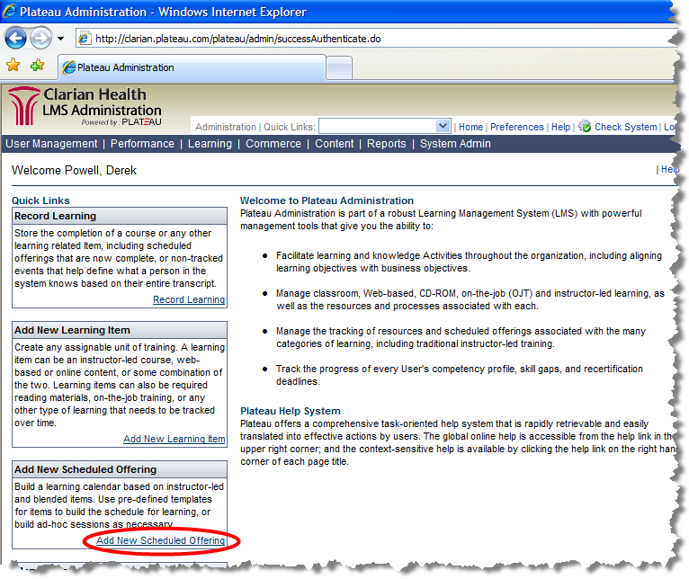  The Add New Scheduled Offering page appears.
2. | In the 1. Select a Type section, verify that Item is selected.  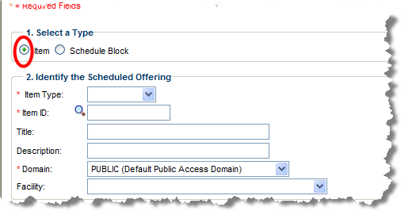
Continued on next page
Basic Tasks for eLMS Administrators, Continued

Creating Scheduled Offerings (continued)

Step | Action
3. | In the 2. Identify the Scheduled Offering section, select the appropriate Item Type from the drop-down menu (key below).  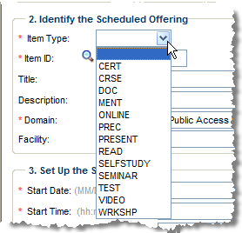  Item Type Key  CERT Certification Course  CRSE Instructor-led, Classroom-based Course  DOC Document  MENT Mentoring  ONLINE Web-based Training Course  PREC Preceptor Course  PRESENT Presentation  READ Read-Only Course  SELFSTUDY Self Study Course  SEMINAR Seminar  TEST Assessment  VIDEO Video Course or Presentation  WRKSHP Workshop
4. | Click the icon next to Item ID.  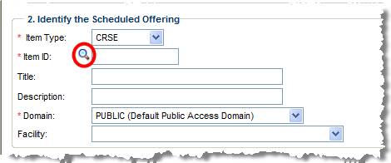  The Items window appears.
Continued on next page
Basic Tasks for eLMS Administrators, Continued

Creating Scheduled Offerings (continued)
Step | Action
4. | Click the Search tab.  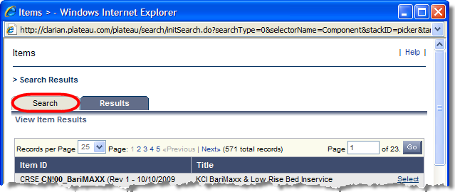  The Search Items screen appears.
5. | Enter your search term in the Item Title field.  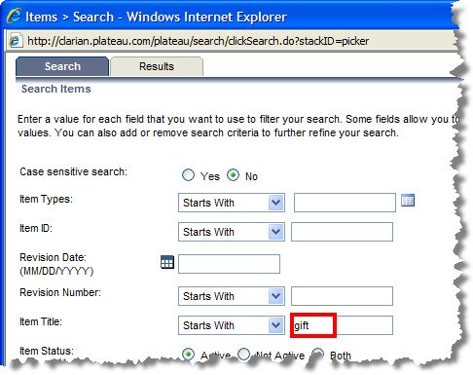  Note: You can change Starts With to Contains to have a more encompassing search.
6. | Click Search.  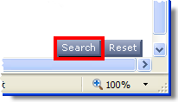  Note: If your search term returns no results, your course may not be an existing offering. Contact the eLMS team at elmssuportmail@clarian.org to enter your new course into the system.
Continued on next page
Basic Tasks for eLMS Administrators, Continued

Creating Scheduled Offerings (continued)
Step | Action
7. | Click Select.  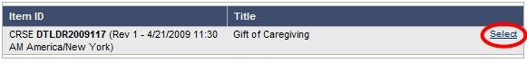  The Add New Scheduled Offering screen reappears with the Item ID field populated.
8. | Select the appropriate Domain (i.e. Public or Specific Audience-based access) from the drop-down menu.  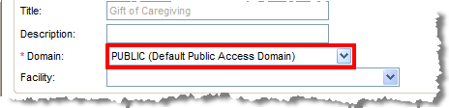
9. | Select the appropriate Facility (i.e. Methodist, Riley, etc.) from the drop-down menu.  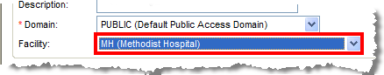
10. | In the Set Up the Segment section, click the calendar next to the Start Date field.  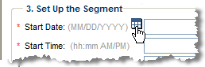  A calendar appears.
Continued on next page
Basic Tasks for eLMS Administrators, Continued

Creating Scheduled Offerings (continued)
Step | Action
10. | Select the appropriate date for the course offering.  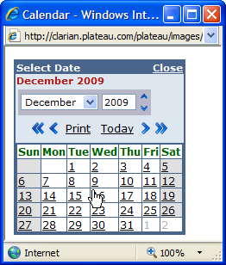
11. | Enter the appropriate time in the Start Time field (example: 09:00 AM).  Note: Be sure to enter a space between number and AM/PM. Additionally, the system will not accept military time.  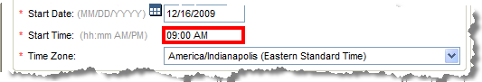
12. | Ensure that the appropriate Time Zone is selected.  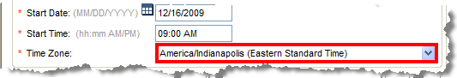
13. | If entering an instructor-led course, in the Select Resources section, click the icon next to the Primary Instructor field.  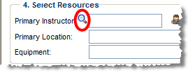  The Instructors screen appears.
Continued on next page
Basic Tasks for eLMS Administrators, Continued

Creating Scheduled Offerings (continued)
Step | Action
12. | Click the Search tab.  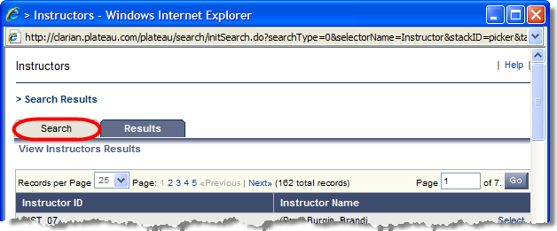
13. | Enter the appropriate name in the Last Name field.  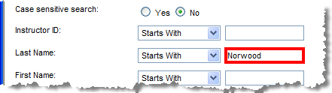
14. | Click the Search button.  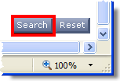
15. | Click Select next to the appropriate name.  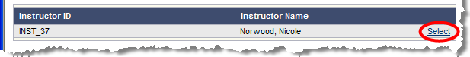  Note: If you instructor does not appear when you search, contact the eLMS team elmssupportmail@clarian.org to enter the instructor’s name into the system.
16. | Enter a Primary Location and any needed Equipment in the corresponding fields.  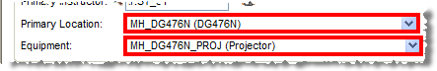
Continued on next page
Basic Tasks for eLMS Administrators, Continued

Creating Scheduled Offerings (continued)

Step | Action
17. | Click the Next button.  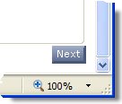  Note: If there are any discrepancies, the Warning Details screen will display.
18. | Click the Next button again.
19. | After reviewing the details, click the Submit button to add your course to eLMS.  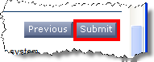  Note: Record the Scheduled Offering ID displayed in the upper left of the Summary screen. This can be used to quickly access or search for the offering.  The scheduled offering record is displayed, allowing you to make  further configurations if needed.

Basic Tasks for eLMS Administrators, Continued

Setting Registration Parameters | Follow the instructions below to set registration parameters.

Step | Action
1. | From the eLMS home page, click the Learning link.  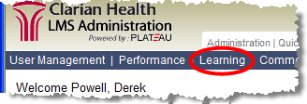
2. | Click the Scheduled Offerings link.  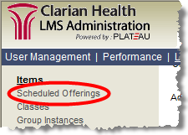
3. | Enter your search criteria/keywords in the field(s) in the Search section (you might need to scroll up to access the Search area).  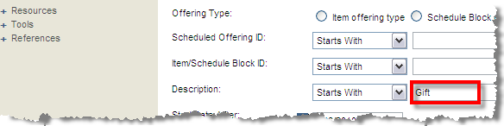  Note: The quickest and most accurate way to search is to enter the Scheduled Offering ID number in the Scheduled Offering ID field.
4. | Click Search.  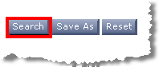  The Search results display.  Note: If no search results display, you may need to change dates in the Start Date After and Start Day Before fields.
Continued on next page
Basic Tasks for eLMS Administrators, Continued

Setting Registration Parameters (continued)
Step | Action
4. | Click the Edit icon next to the appropriate Scheduled Offering.  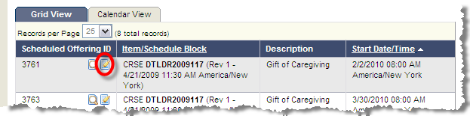
5. | The systems automatically checks Enable Users to Waitlist.  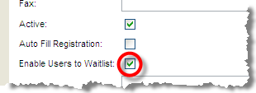
6. | Scroll to the bottom of the Summary tab.
7. | Enter a Registration Cut-off Date.  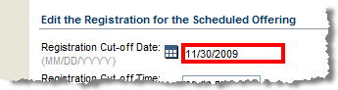
8. | Enter a Registration Cut-off Time.  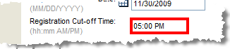
9. | Enter Minimum and Maximum Registration figures.  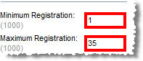
10. | The systems automatically checks Self Registration checkbox.  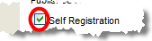
11. | Click to save and apply your changes.
Continued on next page
Basic Tasks for eLMS Administrators, Continued

Registering Users for a Scheduled Offering | Follow the instructions below to register users for a Scheduled Offering.

Step | Action
1. | From the eLMS home page, click the Learning link.
2. | Click the Scheduled Offerings link.
3. | Enter your search criteria/keywords in the field(s) in the Search section (you might need to scroll up to access the Search area).  Note: The quickest and most accurate way to search is to enter the Scheduled Offering ID number in the Scheduled Offering ID field.
4. | Click Search.  The Search results display.
Continued on next page
Basic Tasks for eLMS Administrators, Continued

Registering Users for a Scheduled Offering (continued)

Step | Action
5. | Click the Edit icon.  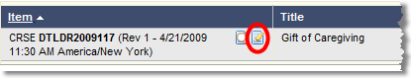
6. | Click the Registration tab.  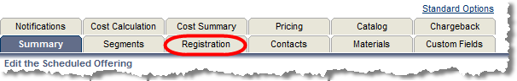
7. | Click the add one or more from list link.  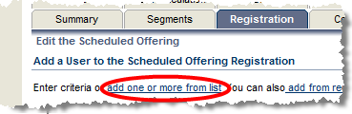  The User screen appears.
8. | Click the Search tab.  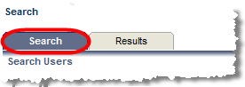
9. | Enter user search criteria in the appropriate fields.  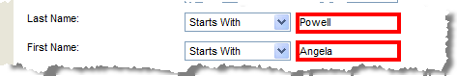  Note: To enable search by Lawson ID, click the Add/Remove Criteria button and then check the Lawson ID Number box. Click the Submit Query button.
10. | Click the Search button.
Continued on next page
Basic Tasks for eLMS Administrators, Continued

Registering Users for a Scheduled Offering (continued)

Step | Action
11. | Click the checkbox(es) next to Email confirmations to: to indicate which individuals should receive email confirmations.  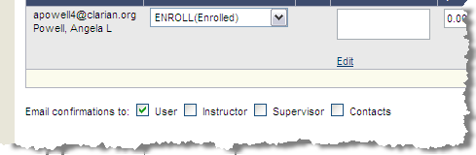
12. | Click the Add button for each user to be added to the Scheduled Offering.  The user is added to the Scheduled Offering. Repeat to add multiple users to a class offering.
Continued on next page

Basic Tasks for eLMS Administrators, Continued

Canceling a Scheduled Offering | Follow the instructions below to cancel a Scheduled Offering.

Step | Action
1. | From the eLMS home page, click the Learning link.
2. | Click the Scheduled Offerings link.
3. | Enter your search criteria/keywords in the field(s) in the Search section (you might need to scroll up to access the Search area).  Note: The quickest and most accurate way to search is to enter the Scheduled Offering ID number in the Scheduled Offering ID field.
4. | Click Search.  The search results display.
Continued on next page
Basic Tasks for eLMS Administrators, Continued

Canceling a Scheduled Offering (continued)
Step | Action
5. | Scroll down to the Cancel the Scheduled Offering link.
6. | Click the Cancel the Scheduled Offering link.  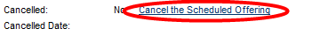
7. | Leave the default Cancellation Date and click .
8. | Check the appropriate checkboxes to add registered users to the item request list, send email notifications, and/or inactivate the Scheduled Offering.
9. | Click .
10. | Click .  The Scheduled Offering is canceled.
Continued on next page
Basic Tasks for eLMS Administrators, Continued

Printing Rosters | Follow the instructions below to print Roster for a Scheduled Offering.

Step | Action
1. | From the eLMS home page, click the Reports link.  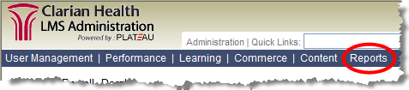  The Reports page appears.
2. | Enter roster in the Search field.  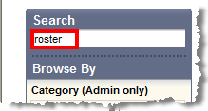
3. | Under Application, check the box next to Admin.  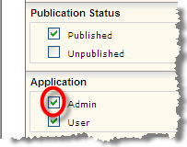
4. | Click .
5. | Click the Scheduled Offering Roster link.  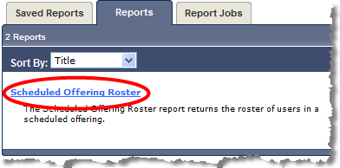
Continued on next page
Basic Tasks for eLMS Administrators, Continued

Printing Rosters (continued)
Step | Action
Enter the Scheduled Offering ID number in the Scheduled Offering field.
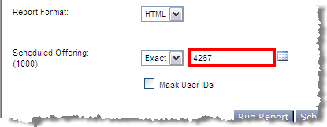

Note: You can click the List icon to begin the process of searching for your Scheduled Offering ID.
6. | Select the appropriate Scheduled Offering (if necessary, click the Search Again link) and click the Submit Selection button.  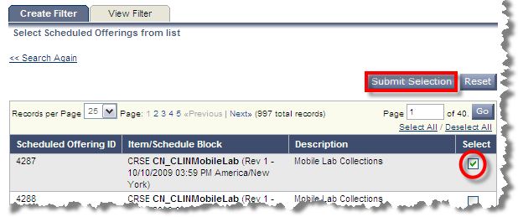
7. | Click the Submit Filter button.  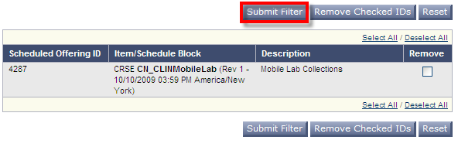
8. | Click the Run Report button.  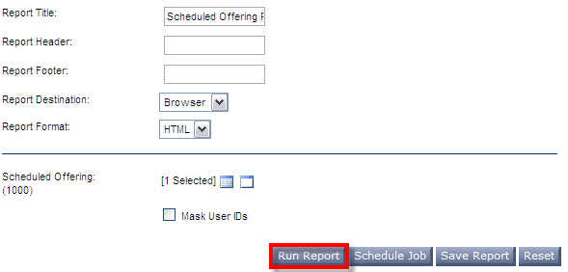
Continued on next page

Basic Tasks for eLMS Administrators, Continued

Printing Rosters (continued)
Step | Action
9. | The Scheduled Offering Roster sheet displays.  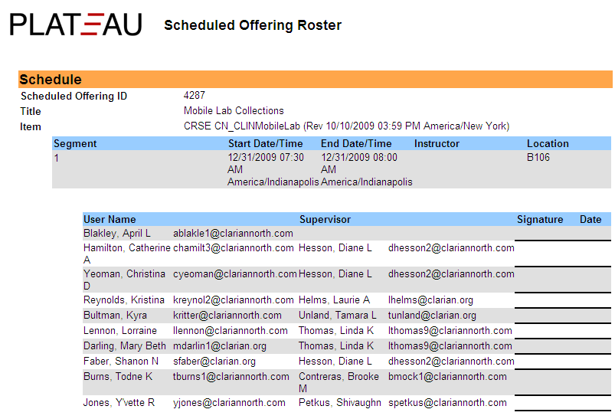
10. | Select File from your browser’s menu bar. Click Print. Complete the steps to print your roster.  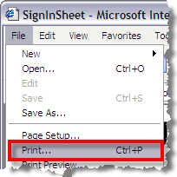

Basic Tasks for eLMS Administrators, Continued

Complete Scheduled Offering Roster for Completion Status | Follow the instructions below to record completion of a course or any learning-related item, including scheduled offerings that are now complete.

Step | Action
1. | From the eLMS home page, click the Record Learning link.  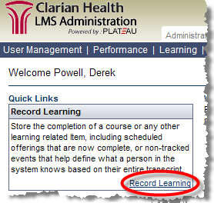  The Record Learning page appears.
2. | Click the Scheduled Offering button.  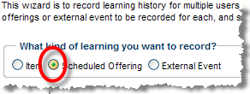
3. | Enter the Scheduled ID Offering number in the Scheduled Offering ID field.  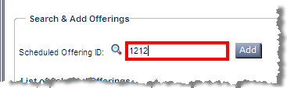  The Items screen appears.  Note: If you don’t have the Scheduled Offering ID number, you can begin the search process by clicking the Magnifying Glass icon.
Continued on next page
Basic Tasks for eLMS Administrators, Continued

Complete Scheduled Offering Roster for Completion Status (continued)
Step | Action
4. | Click the button.  The Scheduled Offering appears in the Search and Add Offerings section.
5. | Under the Search & Add Users section, click the click the next to the User ID field.  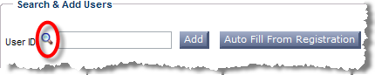  The User screen appears.  Important Note: Click on the Auto Fill from Registration button (pictured above) if your class is a Self-Registration class. Use the Magnifying Glass icon to add students not enrolled. For example: Classes not allowing self-registration would record learning for all students.
6. | Click the Search tab.  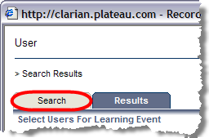
7. | Enter user’s Last Name and First Name.  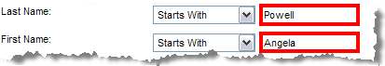  Note: You can also search by Lawson ID number.
Continued on next page

Basic Tasks for eLMS Administrators, Continued

Complete Scheduled Offering Roster for Completion Status (continued)
Step | Action
8. | Click the button.  The Search Results screen appears.
9. | Select the appropriate item by clicking in the checkbox.  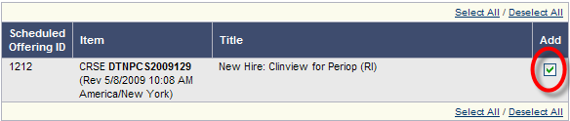
10. | Select the appropriate user by clicking in the checkbox.  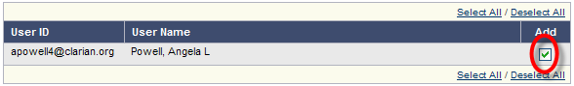
11. | Click the button.  The Scheduled Offering appears in the Search and Add Offerings section.  Note: Repeat Steps 8-13 for multiple users.
12. | Click the Next button.  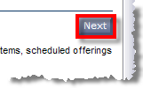  The Record Learningscreen appears.
Continued on next page

Basic Tasks for eLMS Administrators, Continued

Complete Scheduled Offering Roster for Completion Status (continued)
Step | Action
13. | Select the Completion Status from the drop down menu.  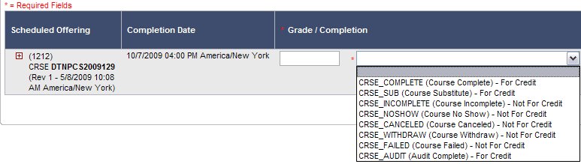
14. | Enter any remaining information in the other non-required fields.  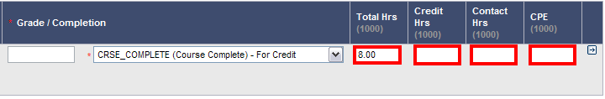  Note: If entering data for multiple users, click to make specific changes to individual users. Be sure to click Apply Changes for each individual user.
15. | Click the Apply Changes button.  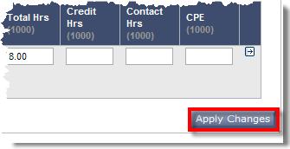  Note: You can view all enrolled participants by clicking on next to Scheduled Offering ID to make any changes before clicking the Next button.
16. | Click the button.
17. | Click the button.  Completion status is entered for the specified users.

Basic Tasks for eLMS Administrators, Continued

Editing Completion Status with the Learning Event Editor | Follow the instructions below to edit Completion Status for course participants using the Learning Event Editor.

Step | Action
1. | Click User Management.  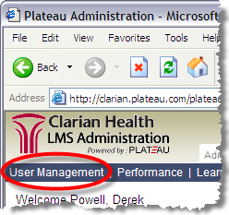  The User Management page appears.
2. | Click Tools.  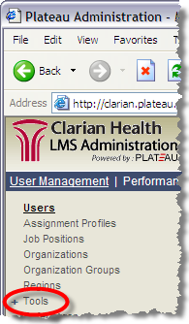
Continued on next page
Basic Tasks for eLMS Administrators, Continued

Editing Completion Status with the Learning Event Editor (continued)
Step | Action
4. | Click Learning Event Editor.  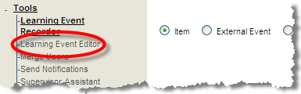  The Learning Event Editor page opens.
5. | Click the arrow button next to Add/Remove Criteria.  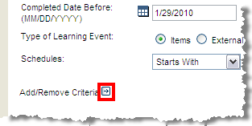
6. | Select Schedules.  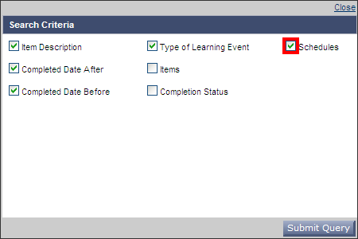
Continued on next page

Basic Tasks for eLMS Administrators, Continued

Editing Completion Status with the Learning Event Editor (continued)
Step | Action
7. | Click the button.
8. | Enter search criteria such as Item Description and Completed Dates (After and Before).  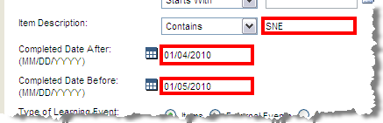
9. | Click the button.
10. | Click the arrow for Completion Status drop-down menu. Select the new status.  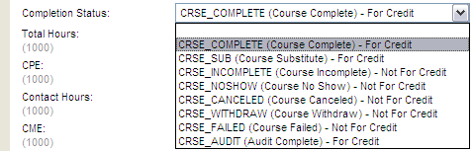
11. | Click the button.  Your changes are applied.

