[Markup] + [Content] + [Outreach] = [SEO]

OnmiSite.com SEO Audit

By John Moore

[Introduction]

The key to receiving more traffic from Google is good markup, relevant content and successful outreach. This quick report will briefly cover how OmniSite.com can use these three search engine optimization (SEO) tactics to get more traffic and increase sales.

[Markup]

Markup or on-page SEO is metadata and Open Graph code that makes content searchable and accessible to search engines and social network users. Figure 1 show the markup that should be Included on ALL OmniSite.com web pages. Here is the code:
http://bit.ly/y3VT9O

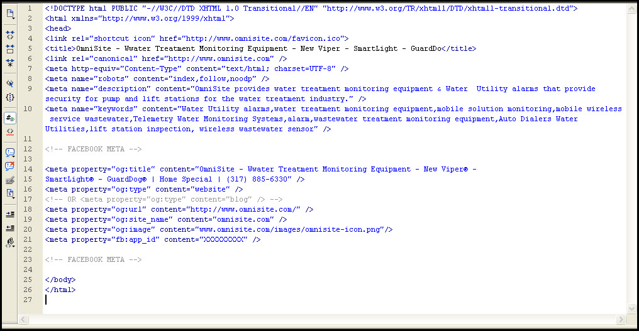
Figure 1.

[Content]

Content is the lifeblood of the Internet. Your content is the vehicle into the mind of those who you want to influence. Your content controls how people perceive you, your company, your message and your brand. Always remember content is not just King, it is everything. Content is EVERYTHING. You need to produce relevant content on a consistent basis (2 to 4 pieces of content per day) to provide relevant information on your products, services and information to people. Create articles on the product and services OmniSite provides or water industry related news. Include infographics, interactive content (HTML5-No Flash), text and video articles to the OmniSite website.
Omnisite.com as of 02/12/2012 has 139 pages indexed by Google. Omnisite.com needs more content. SEO articles and appropriate Keywords used throughout your content so SEO will become part of your website AND over all online publishing standard operation procedure. You must use your keyword list to create better targeted blog posts and content. Using keywords (three keywords sets) that have no search engine marketing (SEM) competition, yet have high Google search results will build affordable traffic. Include these keywords in content and on-page SEO on the OmniSite website:
OmniSite.com Content Keyword List
Keyword | Current Google SE Results
Water Utility alarms | 286,000,000
water treatment monitoring equipment | 103,000,000
mobile solution monitoring | 26,300,000
mobile wireless service wastewater | 24,200,000
mobile water alarm | 18,400,000
remote cellular monitoring | 18,700,000
internet sensor network | 17,900,000
monitoring equipment wastewater industry | 17,300,000
wastewater treatment monitoring equipment | 15,100,000
wireless water alarms | 11,500,000
global wastewater treatment systems | 11,200,000
water treatment plant | 9,830,000
liquid treatment equipment | 9,260,000
Auto Dialers Water Utilities | 3,370,000
Telemetry Water Monitoring Systems | 2,750,000
auto dialer monitoring | 2,510,000
wireless lift station | 1,760,000
lift station inspection | 1,220,00
wireless wastewater sensor | 906,000

[Outreach]

Use link building to create links and social media to gauge general interest and get relevant information. Link build by responding to content by commenting on 5 to 10 relevant websites every day. Here are some relevant website that may provide good link building opportunities:
1. http://www.blog.waterfilters.net/
2. http://watercanada.net/topics/blog/
3. http://watertreatmentsss.com/
5. http://bit.ly/wRqS0i
6. http://www.waterandwastewater.com/
7. http://www.nrwa.org/Default.aspx
8. http://washasia.wordpress.com/
9. http://bit.ly/wgWdhy
10. TreeHugger - http://bit.ly/wQqjiH
11. http://www.ecogeek.org/
12. http://aquafornia.com/
13. http://awramedia.org/mainblog/
14. The Daily Green - http://bit.ly/xjp493
15. http://www.waterworld.com/index.html
16. Water Online - http://bit.ly/AoBOJF
17. http://www.waste-management-world.com/index.html
18. http://www.pennwell.com/index/Water.html

Check your keywords using social media to get a pulse on WHAT people are saying and WHERE they are saying it. Click on these links to see how social media provides insight on what people are thinking:
- water treatment security - Bing Social - http://binged.it/yUFkQu
- wastewater - Bing Social - http://binged.it/wE1tjF
- foursquare - Olivia @ Johnson County Wastewater Treatment Plant - http://4sq.com/wmKTrj
Get listed on the Yahoo! Directory so that OmniSite is on all the major Internet directories. Also, be sure to look for external relevant news and/or content and create linkable content:
- Man caught on tape peeing in reservoir - CBS News http://bit.ly/xo0vdj
- Hacker says he breached Texas water plant - http://on.msnbc.com/xUVscb
- National Water Security Plan for Cities and Towns - Home http://bit.ly/yhmdgF

[Show Them How You Do That Voodoo That You Do So Well]

Create “wow” content covering cool stuff you do. This is a GREAT example:
Sport Graphics – The Lombardi Trophy on the JW Marriott – How did you do that?
http://bit.ly/xgF93p

[Conclusion]

OmniSite.com has the age, content and product to be at least a Google PageRank 4 website. OmniSite.com, currently a PageRank of 2, just needs to tighten the organic SEO by adding (via link building) to the water treatment monitoring equipment community. Using SEO content to provide answers, opinion and comments to the "Googlebase" of users looking for water treatment monitoring equipment content and solutions will provide continuing search engine traffic.
AdWords (lots), Facebook (limited) and twitter advertising (limited) will help to promote the OmniSite brand and add to the overall SEO campaign. Using these and other SEO/SEM tactics will grow the pageviews of OmniSite.com. More pageviews will bring more customers. If I become the SEO Marketing Specialist I will expand on and implement all the techniques included in this SEO audit.

