CollegeUp.org SEO Strategy
Friday, February 26, 2011
Version 1.0

By: J.G. Moore
CollegeUp.org Content: SEO Strategy Overview
Outcomes:
- Document Overview
Search engines algorithms are, without a doubt, sophisticated and evolving. Search engine optimization (SEO) is creating search engine friendly content for the CollegeUp.org website. SEO content will rank higher in search engine queries—ultimately increasing traffic to the collegeUp.org website.
Keyword density, adding relevant keywords to content, is the primary method for creating SEO content. In addition to keyword density the following SEO methods will used:
- Create an SEO Friendly Sitemap - Search engines like SEO friendly Sitemaps
- Focus on Page Titles - Optimized content titles
- Image Content - Image Optimization & SEO naming convention alt text
- Video Content - Use Google Video Sitemaps
- Create and Repurpose Quality Content - USAFunds, NeLA and original content
- Promote CollegeUp.org Content - Ethical linkbuilding and social media
This report documents the CollegeUp.org SEO content strategy—relevant keyword research, URL canonicalization (301 redirects) and competitive analysis—and provides the final content keyword list. These methods will become the standard operating procedure (SOP) for all content creation for the CollegeUp.org website.

Notes:

CollegeUp.org Content: SEO Keyword Research Overview
Outcomes:
- Analyze relevant keywords
- Generate CollegeUp.org Content Keyword List
The first step in the CollegeUp.org SEO strategy is to create a content keyword list. The content keyword list is generated using Google search engine marketing (SEM) data. Google SEM will provide the data needed to create a content keyword list that will grow CollegeUp.org's organic traffic and help students find the answers they need to be successful.
As shown is Figure A, the keyword, "credit card offers" keyword search shows competition, search and trend data.
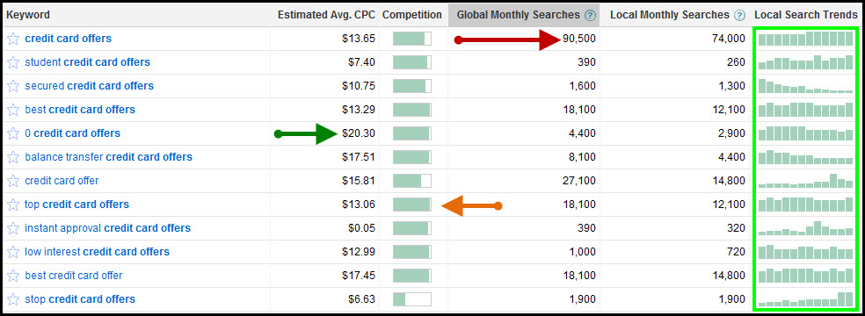
Fig A – Google SEM Keyword data
Competing keyword data is also available for comparison. Other potential keywords are also displayed. To start compiling the content keyword list keywords with high global and local monthly searches are targeted. Cost-per-click (CPC) data is also considered in selecting keywords for the content keyword list. A keyword's valuation or cost-per-click (CPC) is also good indicator of that keywords popularity—the higher the keyword the better.
As shown is Figure A, Keyword competition and local search trends (green box) are also considered in selecting keywords. CPC is used when bidding for search engine marketing (SEM) ad placement. CollegeUp.org’s SEO strategy will focus solely on organic search. See Figure B.
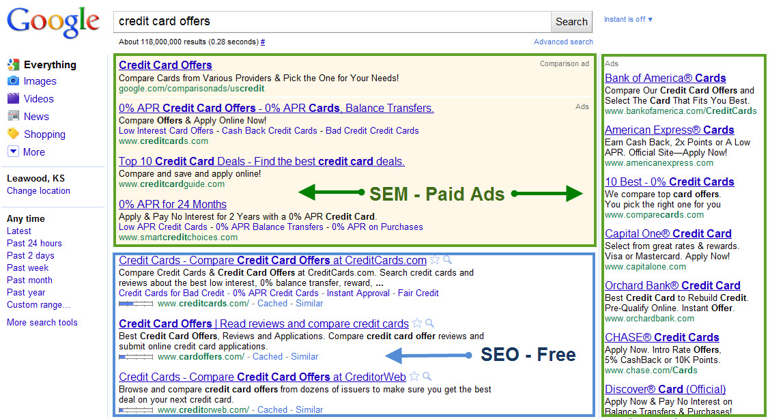
Fig B – Search queries on Google.com Paid vs. Free

Using Keywords with low competition in CollegeUp.org content will result in higher organic (SEO) rankings, higher PageRank and high search volume. Once the initial content keyword list is generated it will be part of all relevant (text, ALT tags, image filenames) content—and by default grow CollegeUp.org search volume.
The content keyword list is a dynamic list that will grow as the CollegeUp.org website and the Google search index grows. The most important use of the content keyword list is providing content will provide users the information they need to be successful.
This report provides keyword analysis that focuses on financial literacy and student loan keywords. Each SEO synopsis will provide quick information on the value, reach and interest of each keyword. Listed below are the financial literacy keywords and student loan analyzed in this report:

college debt | personal budget | debt management | Financial Literacy
direct loans | loan repayment | how to pay off debt | student loans student loans
student loan debt | student loan loan | federal student loan | student loans student

Keyword: Financial Literacy
Ideal Characteristics:
- Universal Financial Keyword
- Used in multiple Google Categories
- Search Interest is above 55%
This keyword has a high (global monthly searches = 49K, local monthly searches = 33K) search volume that will help page rank and organic search (Google) placement. As shown in Figure 1, this keyword and similar keywords also have a low CPC value. Again, keyword CPC is not a concern for our purposes; it is good that this keyword and similar keywords have a good CPC value.
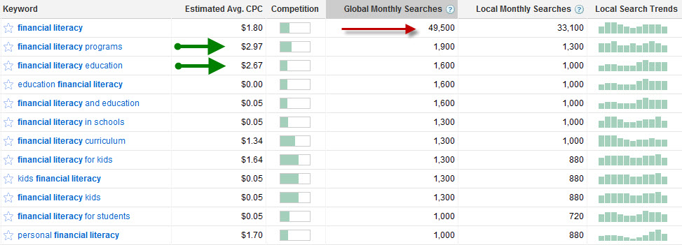
Fig 1 – Keyword queries on Google.com
As shown in Figure 2, the Financial Literacy keyword has been rather steady in recent months. It has built back from a December (Holiday) dip.
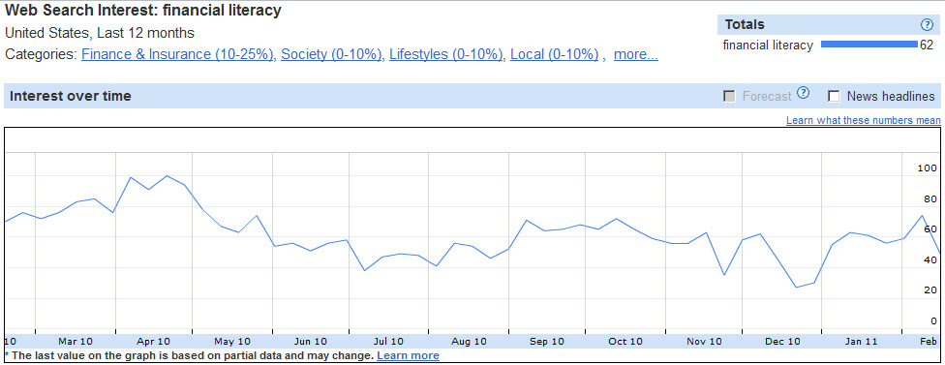
Fig 2 – Keyword Interest over time
The Financial Literacy keyword is popular nationwide, particularly in Oklahoma and the East Coast, as shown in Figure 3. This keyword also has two rising searches over 70%. These top searches and rising searches keywords will also be part of our SEO content strategy via content keyword density and ALT tagging.
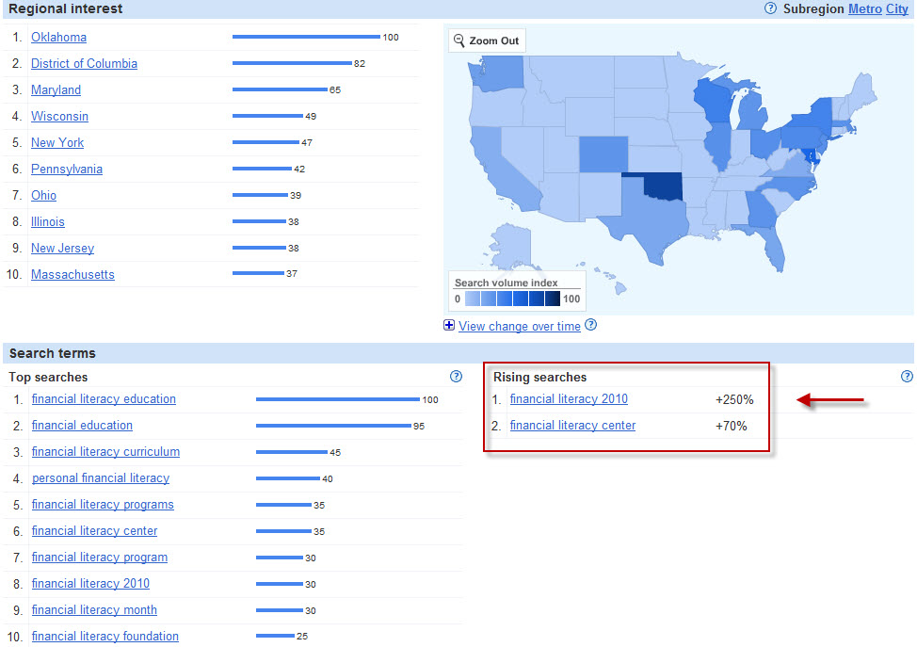
Fig 3 – Keyword Regional Interest, Search Terms and Rising Searches

Notes:

Keyword: Personal Budget
Ideal Characteristics:
- Universal Financial Keyword
- Similar Keywords are popular
- Search Interest is at 50% but steady
- Yearly Spikes
This keyword has a high (global monthly searches = 49K, local monthly searches = 33K) search volume that will help page rank and organic search (Google) placement. As shown in Figure 4, this keyword and similar keywords also have a low CPC and competition.
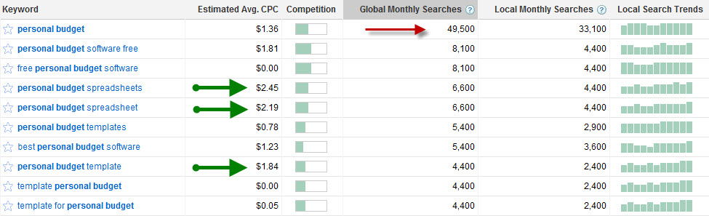
Fig 4 – Keyword queries on Google.com
As shown in Figure 5, the Personal Budget keyword has been steady in recent months with a recent spike (100%) early January (New Year’s Resolutions).
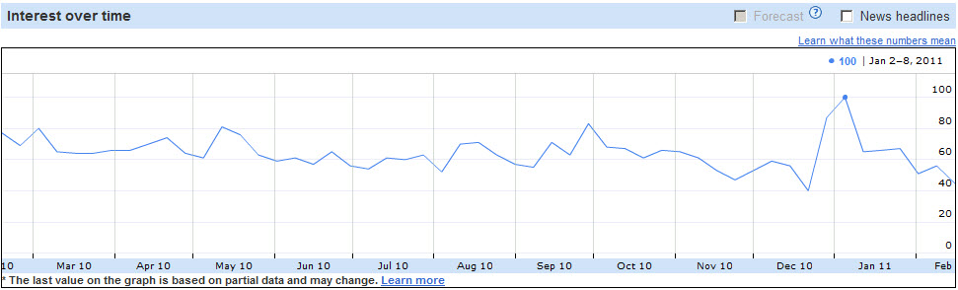
Fig 5 – Keyword Interest over time
The Personal Budget keyword is popular nationwide, as shown in Figure 6. This keyword also has three rising searches over 40%. These top searches and rising searches keywords will also be part of our SEO content strategy via content keyword density, tools, downloadable templates and ALT tagging.
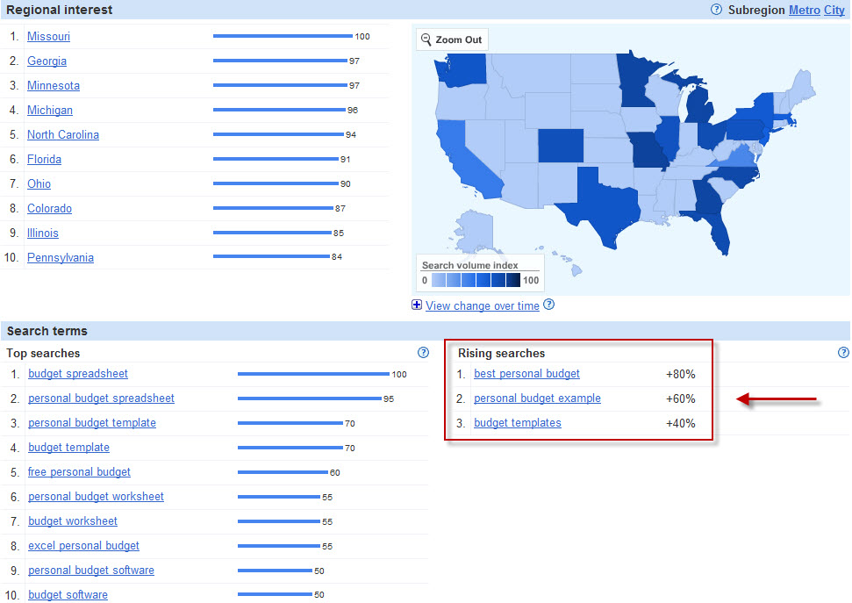
Fig 6 – Keyword Regional Interest, Search Terms and Rising Searches

Notes:

Keyword: Debt Management
Ideal Characteristics:
- Universal Financial Keyword
- Used in multiple Google Categories
- Similar Keywords are popular
- Search Interest is above 60%
This keyword has a high (global monthly searches = 201K, local monthly searches = 60K) search volume that will help page rank and organic search (Google) placement. As shown in Figure 7, this keyword and similar keywords also have high CPC, competition and monthly search volume.
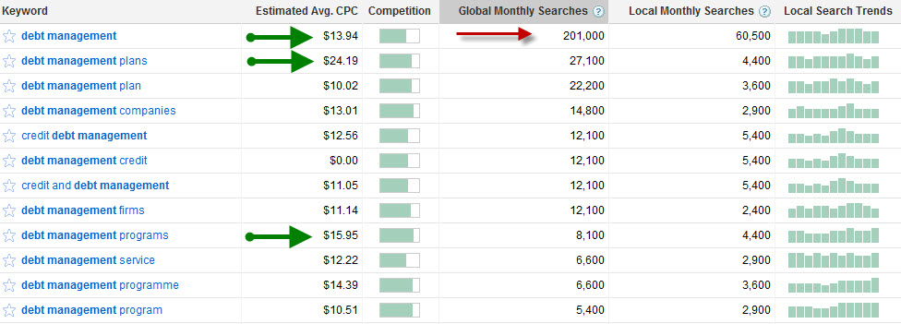
Fig 7 – Keyword queries on Google.com
As shown in Figure 8, the Debt Management keyword has been fairly steady in recent months. Debt Management keyword volume was down but is building again.
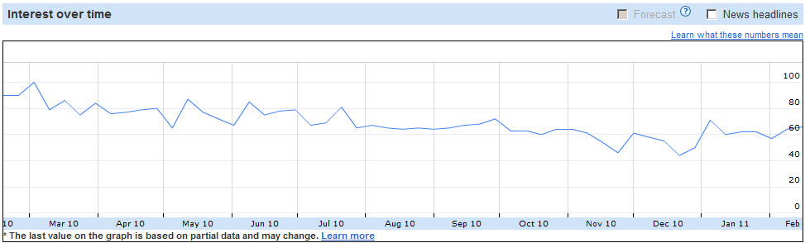
Fig 8 – Keyword Interest over time

The Debt Management keyword is popular nationwide, as shown in Figure 9. This keyword also has six rising searches over 60% and three over 100%. Two of the Debt Management top searches are at 100% illustrating that this keyword is associated with other strong keywords. These top searches and rising searches keywords will also be part of our SEO content strategy via content keyword density and ALT tagging.
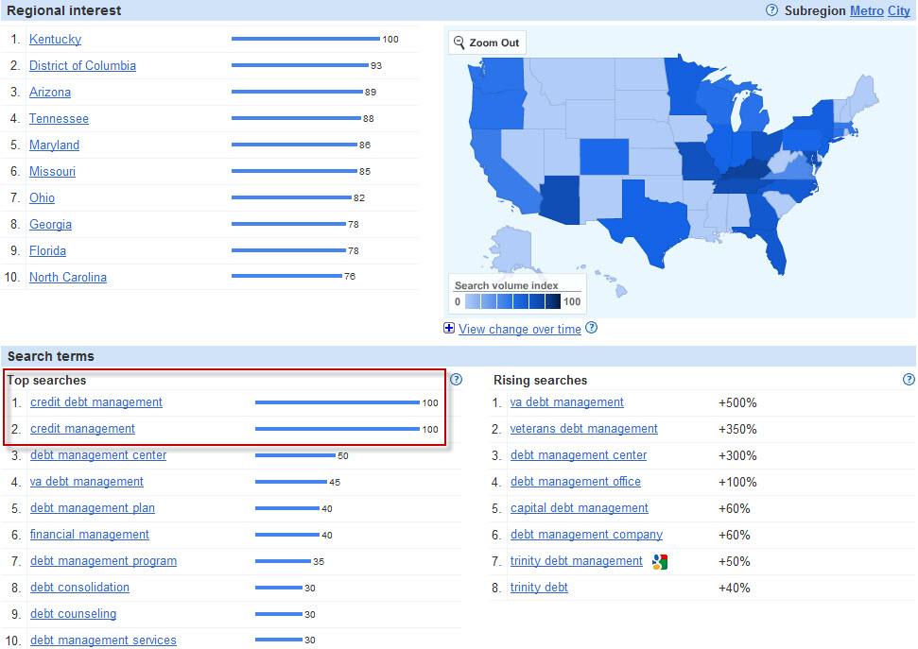
Fig 9 – Keyword Regional Interest, Search Terms and Rising Searches

Notes:

Keyword: College Debt
Ideal Characteristics:
- Specific Financial Search Keyword
- Targeted Financial Google Categories
- Search Interest is at 60%
The College Debt keyword has a moderate (global monthly searches = 14K, local monthly searches = 12K) search volume that will help page rank and organic search (Google) placement. As shown in Figure 10, the College Debt keyword has high CPC and low competition. Search volume is moderate, but growing each month.
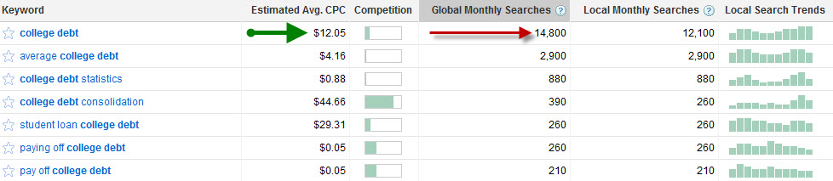
Fig 10 – Keyword queries on Google.com
As shown in Figure 11, the College Debt keyword has been steady in recent months with a recent spike (100%) early December.
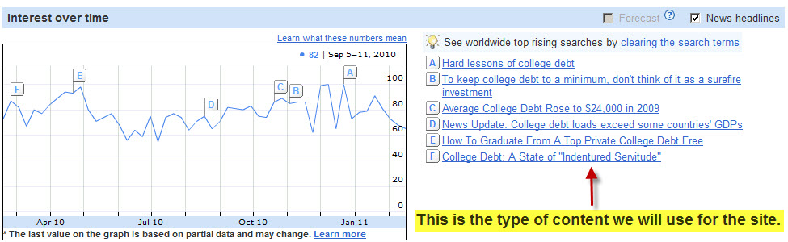
Fig 11 – Keyword Interest over time and SEO content sources
The College Debt keyword is popular nationwide, as shown in Figure 11. This keyword does not have strong rising searches, but three of the College Debt top searches are above 90% illustrating this keyword is associated with other strong keywords. These top searches and rising searches keywords will also be part of our SEO content strategy via content keyword density, tools and ALT tagging.
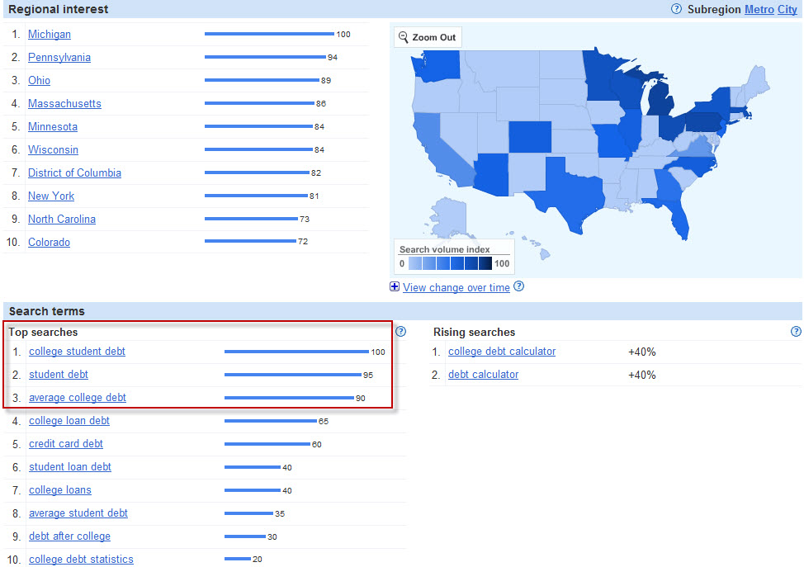
Fig 11– Keyword Regional Interest, Search Terms and Rising Searches

Notes:

Keyword: Student Loan Debt
Ideal Characteristics:
- Specific Financial Search Keyword
- Targeted Financial Google Categories
- Search Interest is at 60%
The Student Loan Debt keyword has a moderate (global monthly searches = 22K, local monthly searches = 22K) search volume that will help page rank and organic search (Google) placement. As shown in Figure 12, this keyword has a very high CPC, moderate competition and moderately steady search volume.
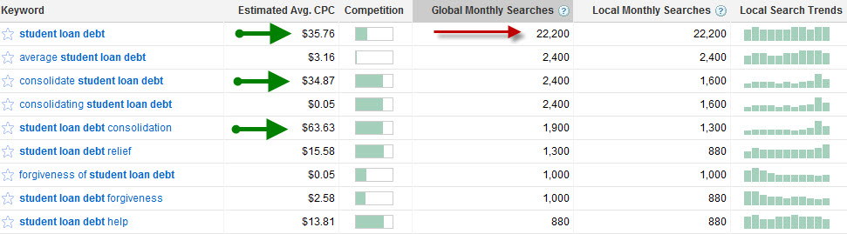
Fig 12 – Keyword queries on Google.com
As shown in Figure 13, the Student Loan Debt keyword volume has been steady.
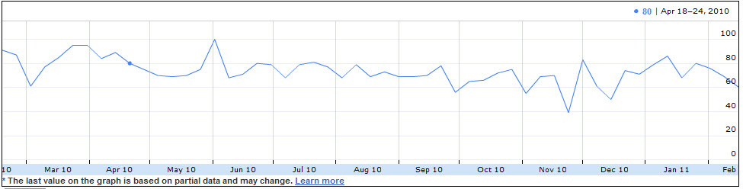
Fig 13 – Keyword Interest over time
The Student Loan Debt keyword is popular nationwide, as shown in Figure 14. This keyword has very strong top searches and moderate but growing rising search volume. Three of the Student Loan Debt top searches are at 100% illustrating that this keyword is associated with other strong keywords. These top searches and rising searches keywords will also be part of our SEO content strategy via content keyword density tools and ALT tagging.
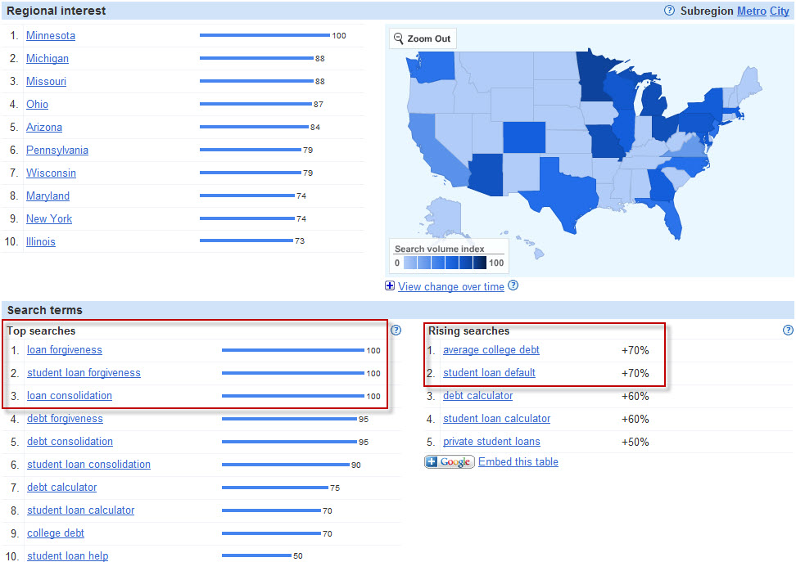
Fig 14– Keyword Regional Interest, Search Terms and Rising Searches
Notes:

Keyword: Federal Student Loan
Ideal Characteristics:
- Specific Financial Search Keyword
- Targeted Financial Google Categories
- Search Interest is above 60%
The Federal Student Loan keyword has a moderate (global monthly searches = 49K, local monthly searches = 40K) search volume that will help page rank and organic search (Google) placement. As shown in Figure 15, this keyword has low competition and moderate to high monthly search volume. Similar keywords have high (110K and 74K) search volume.
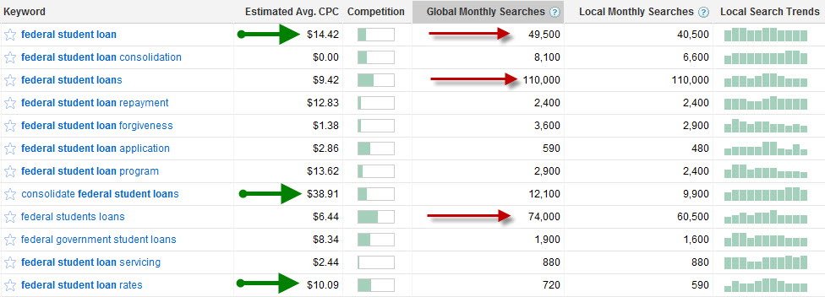
Fig 15 – Keyword queries on Google.com
As shown in Figure 16, the Federal Student Loan keyword volume has been steady.
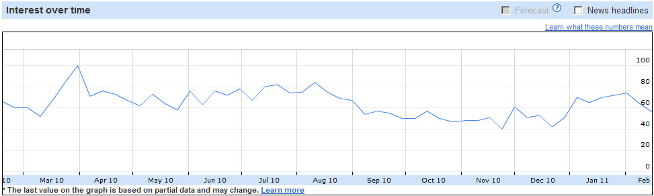
Fig 16 – Keyword Interest over time – Down from spring of 2010 but steady
The Federal Student Loan keyword is popular nationwide, as shown in Figure 17. This keyword has very strong top searches and low but growing rising search volume. Three of the Federal Student Loan top searches are at 100% illustrating that this keyword is associated with other strong keywords. These top searches and rising searches keywords will also be included in our SEO content strategy via content keyword density and ALT tagging.
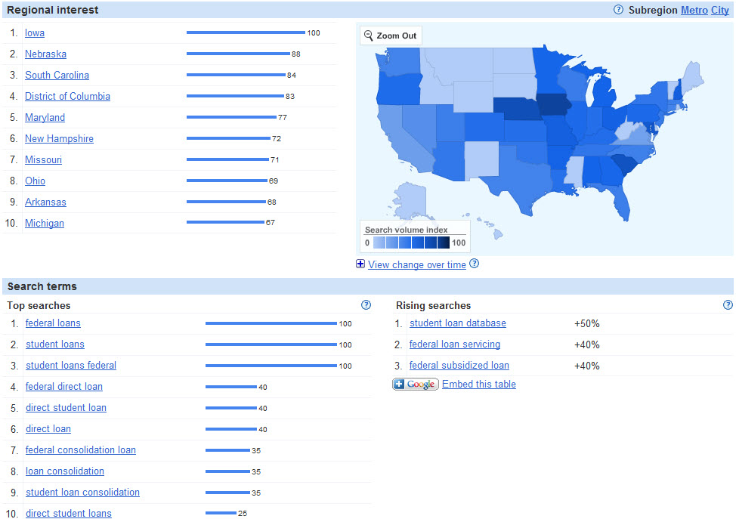
Fig 17 – Keyword Regional Interest-Search Terms and Rising Searches
Notes:

Keyword: Direct Loans
Ideal Characteristics:
- Specific Financial Search Keyword
- High Monthly Searches
- Search Interest is above 60%
The Direct Loans keyword has a high (global monthly searches = 673K, local monthly searches = 550K) search volume that will help page rank and organic search (Google) placement. As shown in Figure 18, this keyword has low competition and high monthly search volume. Similar keywords have high (90K and 60K) search volume.
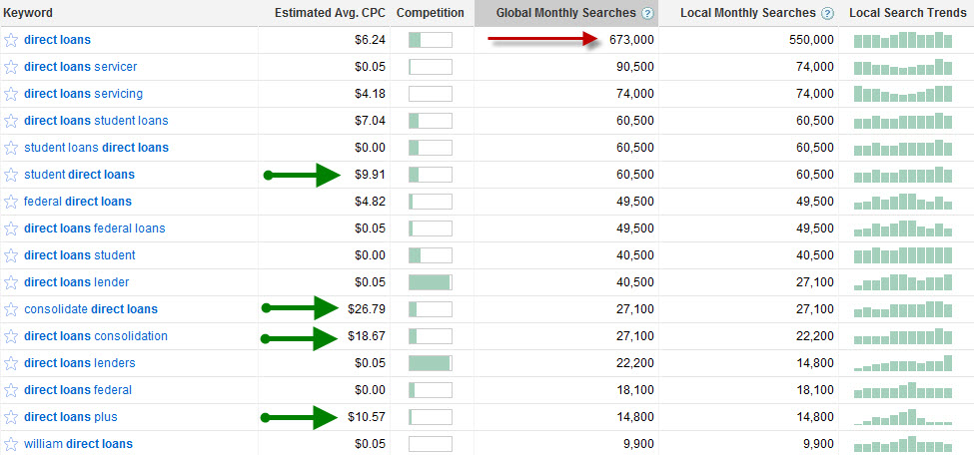
Fig 18 – Keyword queries on Google.com
As shown in Figure 19, the Direct Loans keyword volume is growing after a slight dip.
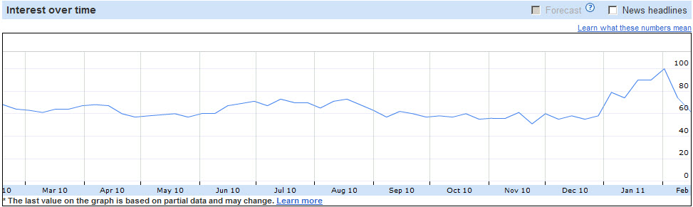
Fig 19 – Keyword Interest over time – Very steady and growing search volume
The Direct Loans keyword is popular nationwide, as shown in Figure 20. This keyword has strong to moderate top searches and *Breakout rising search volume. Three of the Direct Loans rising searches are above 90% (one breakout) illustrating that this keyword is associated with other strong keywords. These top searches and rising searches keywords will also be part of our SEO content strategy via content keyword density and ALT tagging.
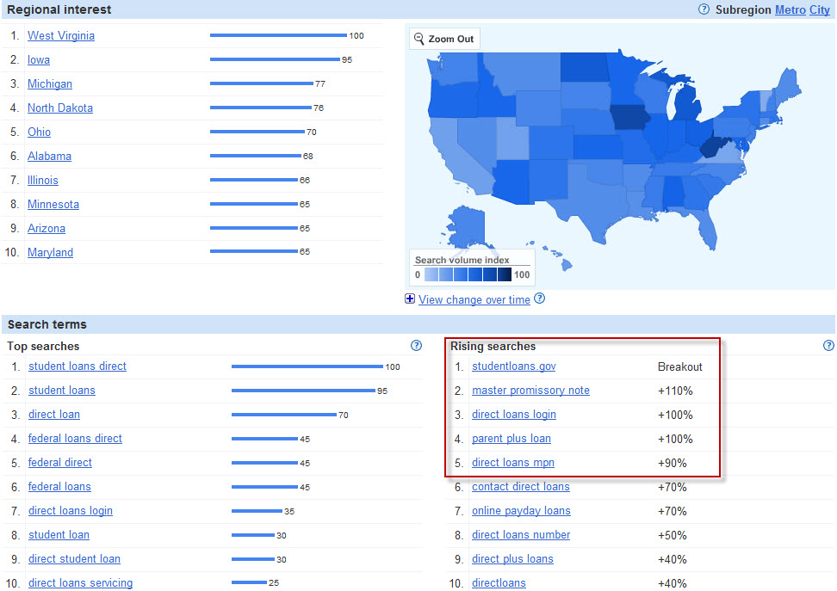
Fig 20 – Keyword Regional Interest-Search Terms and Rising Searches
* Breakout is search volume growth greater than 5000%.
Notes:

Keyword: Loan Repayment
Ideal Characteristics:
- Specific Financial Search Keyword
- High Monthly Searches
- Search Interest is above 60%
The Loan Repayment keyword has a high (global monthly searches = 165K, local monthly searches = 90K) search volume that will help page rank and organic search (Google) placement. As shown in Figure 21, this keyword has low competition and high monthly search volume. Similar keywords have high (60K and 49K) search volume.
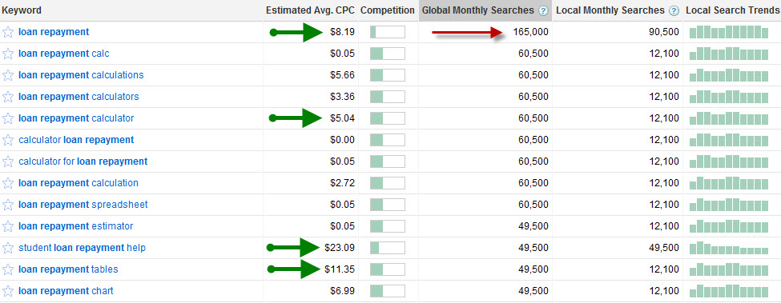
Fig 21 – Keyword queries on Google.com
As shown in Figure 22, the Loan Repayment keyword volume is steady.
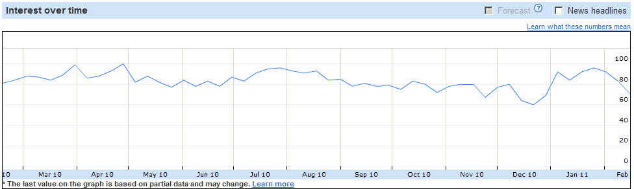
Fig 22 – Keyword Interest over time – Very steady and growing search volume

The Loan Repayment keyword is popular nationwide, as shown in Figure 23. This keyword has strong to moderate top searches and *Breakout rising search volume. Although the breakout term is not our content focus, having a breakout keyword in rising searches is a good indicator of the Loan Repayment keyword’s SEO strength.
Four other rising search keywords are applicable to CollegeUp.org content. Two of the Loan Repayment top searches are above 90% illustrating the Loan Repayment keyword is associated with other strong keywords. These top searches and rising searches keywords will also be part of our SEO content strategy via content keyword density and ALT tagging.
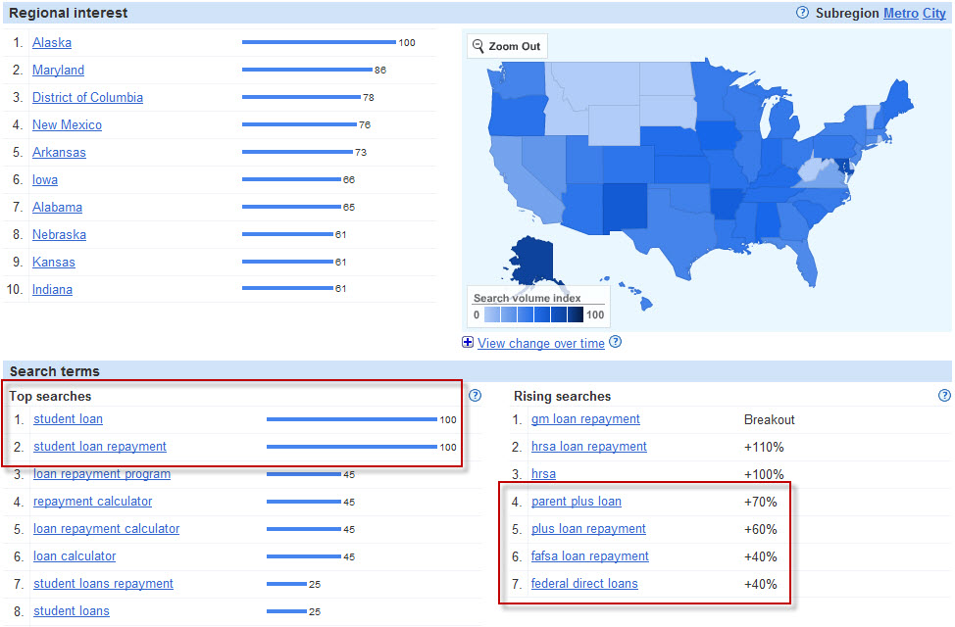
Fig 23 – Keyword Regional Interest-Search Terms and Rising Searches
* Breakout is search volume growth greater than 5000%.
Notes:

Keyword: How to pay off debt
Ideal Characteristics:
- Specific (longtail) Financial Search Keyword
The How to pay off debt keyword has a low (global monthly searches = 9K, local monthly searches = 8K) search volume that will help page rank and organic search (Google) placement. As shown in Figure 24, this keyword has high competition and low monthly search volume. Similar keywords have low (1K and 73) search volume.
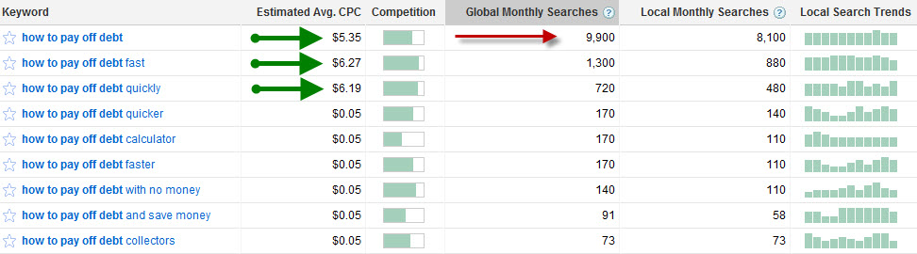
Fig 24 – Keyword queries on Google.com
As shown in Figure 25, the How to pay off debt keyword volume is steady.
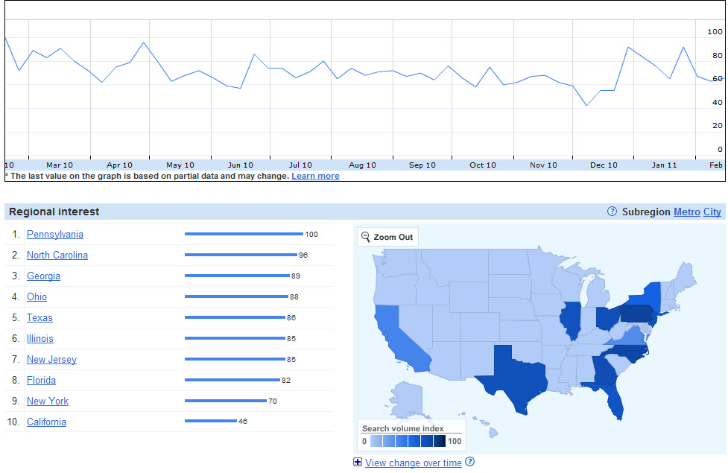Fig 25 – Keyword and Regional Interest
The How to pay off debt keyword is all about SEO strength. This is a longtail keyword that will not have search volume but will have staying power. People will always use this search term. As shown in Figure 26, the How to pay off debt keyword is embedded in evergreen content. Using the How to pay off debt keyword in CollegeUp.org content will add SEO value by link building and organic search vial long tail users search queries. The How to pay off debt keyword will be part of in our SEO content strategy via content keyword density and ALT tagging.
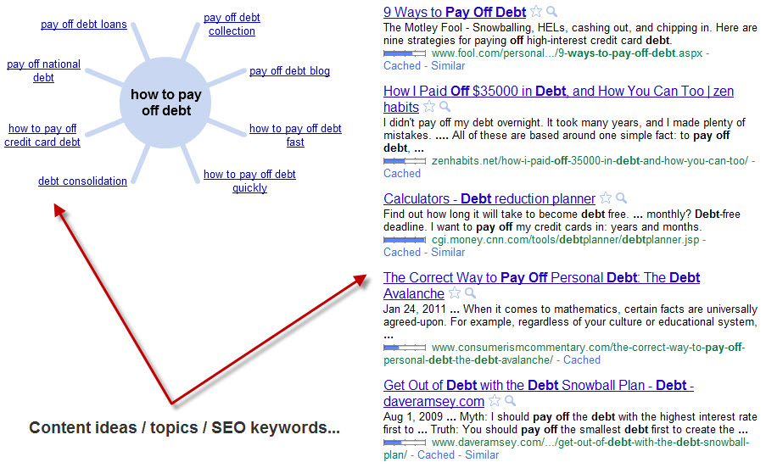
Fig 26 – Keyword topics and content reach

Notes:

SEO Tactic: URL Canonicalization
Ideal Characteristics:
- Capture High Search Engine Volume
The next three keywords are different from the previous nine. These keywords SEO strength is in using URL canonicalization. URL canonicalization is using 301 redirects to point one URL to another URL. Using a 301 redirect is a White Hat method that is sanctioned by Google, Yahoo, Bing, Baidu and most other search engines.
Canonicalization consolidates Google PageRank. Better PageRank means that your website’s Google crawl rate increases. URL canonicalization of high search volume keywords will push CollegeUp.org to the top position in Google’s organic search results. The more the Googlebot crawls CollegeUp.org the better CollegeUp.org’s PageRank and organic search volume will be.
URL canonicalization using a 301 redirect works like this:
- Find a keyword that has a high search volume
- Buy that keyword's URL.
- Use a 301 redirect on the Keyword URL to point to a section of another URL
Three keywords have the potential to help grow CollegeUp.org’s organic traffic:
- student loans student loans
- student loans loans
- student loans student
As shown in Figure 27, these keyword URLs are available for purchase and matches with some of CollegeUp.org’s content offerings.
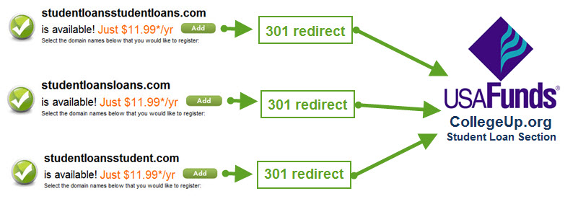Fig 27– URL Canonicalization of high traffic keywords to relevant section of a website
Keyword/KeywordURL: Student Loans Student Loans
Ideal Characteristics:
- Specific College Financial Search Keyword
- High Targeted Search Engine Volume
- Search Interest is above 60%
The student loans student loans, student loans loans and student loan student loan keywords each have high (average global monthly searches = 1.7 million, local monthly searches = 1.2 million) search volume that will help page rank and organic search (Google) placement. As shown in Figure 28, some of these keywords have a moderate competition and all have a high monthly search volume. Similar keywords have high (1 million and 823K) search volume.
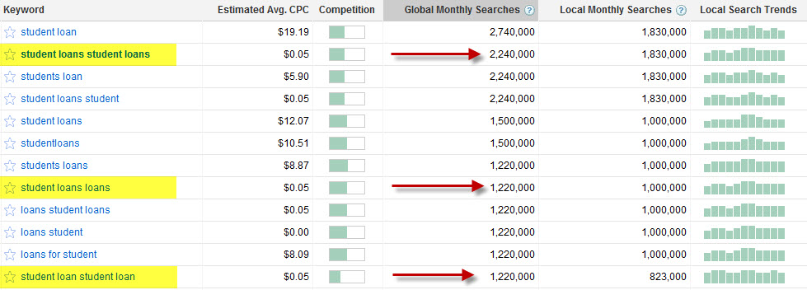
Fig 28 – Keyword queries on Google.com
As shown in Figure 29, the student loans student loans keyword volume is steady.
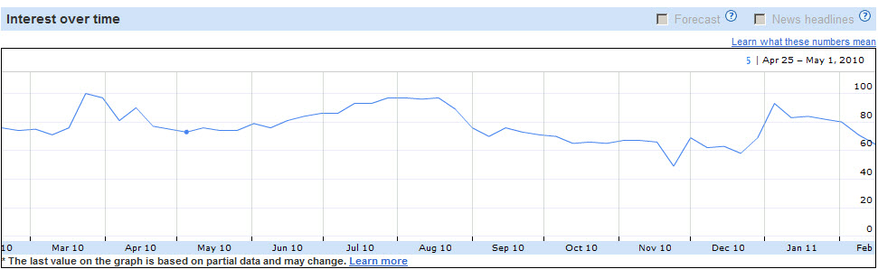
Fig 29 – Keyword Interest over time – steady search volume

The student loans student loans keyword is popular nationwide, as shown in Figure 30. This keyword has strong to moderate top searches and *Breakout rising search volume. Three of the student loans student loans rising searches are above 100% (one breakout) illustrating that this keyword is associated with other strong keywords and searches.
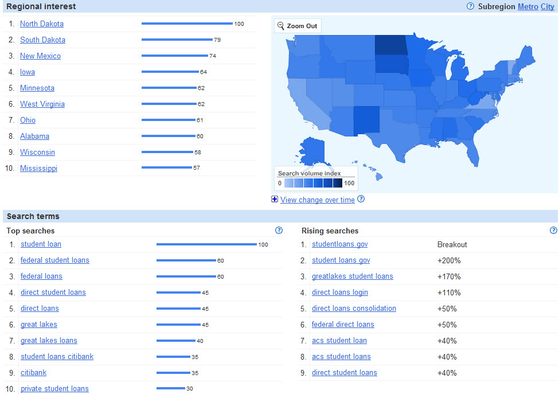
Fig 30 – Keyword Regional Interest-Search Terms and Rising Searches * Breakout is search volume growth greater than 5000%.
These three keywords, student loans student loans, student loans loans and student loan student loan, have a combined global search volume of 4,680,000 searches per month. URL canonicalization could potentially generate the following monthly search volume for CollegeUp.org:

% of Captured MGSV | Actual Google MGSV | CollegeUp Captured MGSV
2% | 4,680,000 | 93,600
10% | 4,680,000 | 468,000
20% | 4,680,000 | 936,000
MGSV = Monthly Google Search Volume (Global)
CollegeUp.org Content: SEO Strategy Conclusion
Outcomes:
- SEO as part of content creation / content repurposing
- Grow organic search volume
- Help students find relevant information
SEO is all about time, planning and implementation. CollegeUp.org’s content will
use three core methods to provide relevant information for students while growing
organic search volume:

• Relevant content — Relevant content will get CollegUp.org indexed faster.
• Updates — Frequent content updates will get CollegUp.org indexed faster.
• SEO as SOP — Persistent SEO will get CollegUp.org more search volume.

I have compiled a content keyword list of *740 keywords that will provide SEO for the CollegeUp.org website. All new and repurposed CollegeUp.org content will contain these keywords. Keyword density will not exceed 5%. The keywords will also be part of the naming convention for images and other media included with the CollegeUp.org content offering. Here are the keywords:

www.kubepharm.com/SEO/Keywords/Managing-time/89-Managing-Time-Keywords.html
www.kubepharm.com/SEO/Keywords/Committing/132-Committing-Keywords.html
www.kubepharm.com/SEO/Keywords/Finance/450-Finance-Keywords.html
www.kubepharm.com/SEO/Keywords/Prospetive-Student/30-Prospetive-Students.html
www.kubepharm.com/SEO/Keywords/Ask-Experts/14-Questions-Answers.html
www.kubepharm.com/SEO/Keywords/Current-Students/25-Current-Students.html

Implementing this SEO strategy in repurposed content (USA Funds/NeLA publications) and conversational articles (Blog Post, Infographics) will grow CollegeUp.org’s organic search volume while providing the CollegeUp.org audience the information they need to be successful.

Notes:

* This list will grow as the project progresses.
CollegeUp.org Content: SEO Samples
Outcomes:
- Article –Text Content with Image, Embedded Video and Web Resource
- Article –Text Content with Image and Web Resource
- Q&A –Text Content and Web Resource
Here are the current CollegeUp.org content samples:
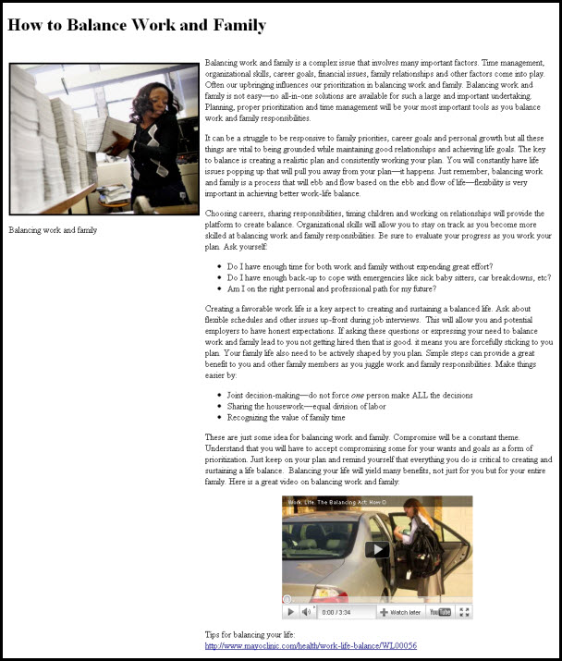

http://www.kubepharm.com/SEO/Content/Articles/How-to-balance-work-and-family.html
http://www.kubepharm.com/SEO/Content/Articles/How-to-better-manage-family-responsibilities-while-attending-college.html

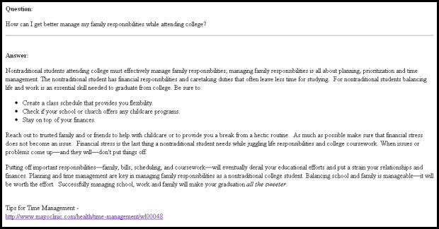
http://www.kubepharm.com/SEO/Content/Q-&-A/How-can-I-get-better-manage-my-family-responsibilities-while-attending-college.html

CollegeUp.org Content: SEO Sitemap
Outcome:
- SEO Sitemap
Here is the current CollegeUp.org Sitemap:

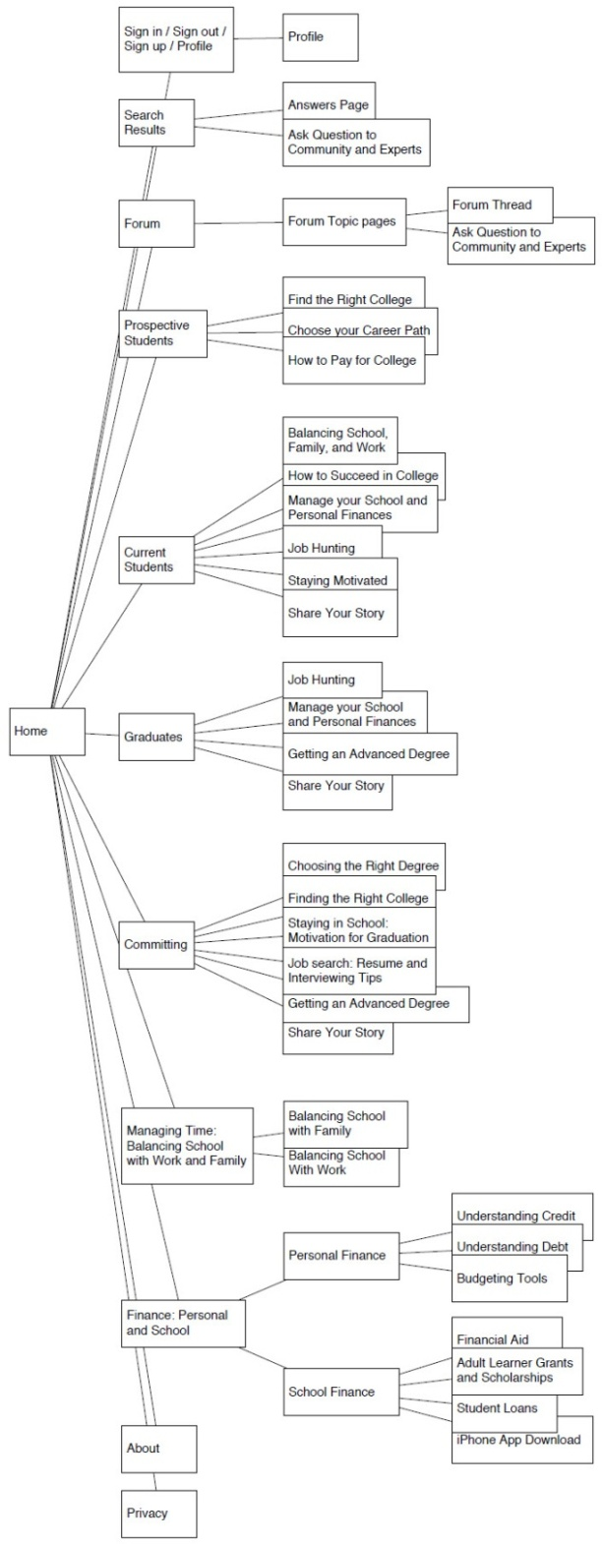
This will be the basis for the (http://www.collegeup.org/sitemap.xml) sitemap.

